**HTML Syllabus**

**1. Introduction to HTML :**

● Understanding HTML and its role in web development  HTML syntax and structure

**2. Text Formatting :**

* Headings, paragraphs, and line breaks
* Formatting text with bold, italic, and underline
* Working with lists (unordered, ordered, and definition lists)

**3. Hyperlinks and Navigation :**

* Creating hyperlinks to link pages within a website
* Linking to external resources
* Creating anchor tags for in-page navigation  Building navigation menus

**4. Images and Multimedia :**

* Inserting and displaying images
* Configuring image attributes (size, alignment, alt text)  Embedding videos and audio files

**5. Tables :**

* Creating tables and defining table structure
* Adding headers, rows, and columns  Formatting tables with CSS

**6. Forms and Input :**

* Building forms to collect user input
* Understanding form elements (text fields, checkboxes, radio buttons, dropdowns)  Handling form submission

**7 . CSS and Styling :**

* Overview of CSS and its role in web design
* Inline styles, internal stylesheets, and external stylesheets
* Applying styles to HTML elements (text formatting, backgrounds, borders)

**8 . Semantic HTML :**

* Understanding the importance of semantic markup
* Using semantic elements like <header>, <nav>, <article>, <section>, etc.

**9. HTML5 Features :**

* Introduction to HTML5 and its new elements
* Working with multimedia elements like <video>, <audio>
* Using new form input types like <input type="date">, <input type="email">

**10. Responsive Web Design :**

* Designing websites that adapt to different screen sizes
* Using media queries to apply styles based on screen dimensions  Creating fluid layouts with CSS

**11. Accessibility and Usability :**

* Ensuring websites are accessible to all users
* Implementing proper semantic structure for screen readers
* Using appropriate alt text for images
* Keyboard navigation and focus management

**12. HTML and JavaScript Integration :**

* Incorporating JavaScript code into HTML pages
* Handling events and interacting with the DOM

**1.1 Introduction to HTML**

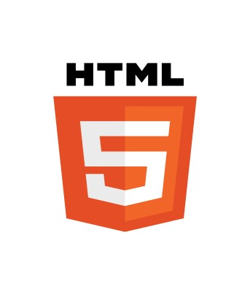

HTML (Hypertext Markup Language) is the bedrock of the modern web. It serves as the standard markup language for creating webpages and defining their structure. In this article, we will delve into the intricacies of HTML, exploring its key concepts, elements, and their role in shaping the digital landscape.

At its core, HTML consists of a series of tags that enclose content, providing meaning and structure. These tags, represented by angle brackets **(< and >)**, are used to define headings, paragraphs, lists, images, and various other elements that compose a webpage. Each HTML tag carries semantic significance, allowing search engines and assistive technologies to understand the content better.

The structure of an HTML document typically comprises an opening **<!DOCTYPE html>** declaration, followed by an **<html>** element that serves as the root of the document. The <head> section houses metadata, including the page title, character encoding, and external stylesheets or scripts. The **<body>** section contains the visible content displayed on the webpage.

To enhance accessibility, HTML provides a range of semantic elements, such as **<header>, <nav>, <main>, <article>,** and **<footer>.** These elements offer clearer outlines of a webpage's structure, making it easier for users and search engines to comprehend the content's organization.

In addition to the standard tags, HTML5 introduced numerous new features, including multimedia elements like **<video>** and **<audio>,** form enhancements with new input types **(<input type="date">, <input type="email">),** and support for scalable vector graphics **(<svg>).**

Understanding HTML lays the foundation for effective web development. It enables you to create well-structured, accessible, and search engine-friendly webpages. By grasping the semantic nature of HTML and harnessing its power, you can design immersive digital experiences that seamlessly blend form and function.

**1.2 HTML syntax and structure.**

HTML **(Hypertext Markup Language)** follows a specific syntax and structure. Here's an overview of HTML syntax and structure:

*1.* **HTML Document Structure:**

* An HTML document starts with a document type declaration **<!DOCTYPE html>,** which informs the browser that the document is written in HTML5.
* The **<html>** element serves as the root element and contains the entire HTML document.
* Inside the <html> element, there are two main sections: the **<head>** and the **<body>**.The **<head>** Section:

2. **The <head> section :**

* contains metadata and other non-visible information about the document.
* It typically includes the **<title>** element, which specifies the title of the webpage displayed in the browser's title bar or tab.
* Other commonly used elements in the **<head>** section include **<meta>** for defining character encoding, viewport settings, and other metadata, as well as **<link>** for linking external stylesheets or scripts.

*3.* **The <body> Section:**

* The **<body>** section contains the visible content of the webpage.
* It can contain various HTML elements, such as headings **(<h1> to <h6>),** paragraphs **(<p>),** images **(<img>)**, links **(<a>),** lists **(<ul>, <ol>, <dl>),** and more.
* Elements in the **<body>** section define the structure, layout, and content of the webpage.

***4.* HTML Elements :**

* HTML elements are represented by tags, enclosed within angle brackets **(< and >).**
* Most HTML elements have an opening tag and a closing tag. For example,

**<p>** represents the opening tag for a paragraph, and **</p>** represents the closing tag.Some elements are self-closing and do not require a closing tag. For example, the **<img>** tag for an image is self-closing.

* Elements can have attributes, which provide additional information or modify the behavior of the element. Attributes are specified within the opening tag and follow the element's name.

***5.* Nesting and Hierarchy:**

* HTML elements can be nested inside other elements, creating a hierarchical structure.
* For example, a paragraph element **<p>** can contain other elements like text, links, images, etc.
* Proper indentation and formatting enhance the readability and maintainability of the code.

**Here's an example of a simple HTML document structure:**

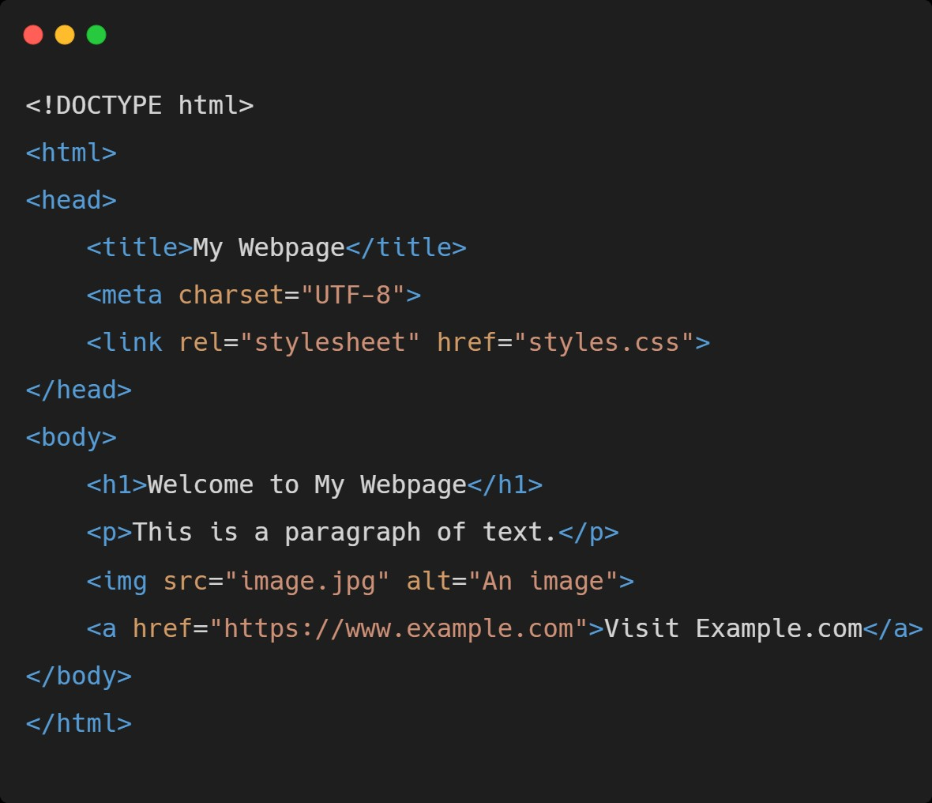

In this example, the document starts with the **<!DOCTYPE html>** declaration, followed by the root **<html>** element. The <head> section contains the document title, character encoding, and a link to an external CSS file. The **<body>** section contains a heading, a paragraph, an image, and a hyperlink.

Understanding HTML syntax and structure is crucial for building webpages that are well-formed and semantically structured.

**1.3 HTML syntax and structure.**

When it comes to HTML (Hypertext Markup Language), understanding the basic tags and elements is essential for building webpages. These fundamental components provide structure and meaning to the content. Let's explore some of the essential ones:

1. **Headings (<h1> to <h6>):** Headings are used to indicate the hierarchy and importance of text on a webpage. The **<h1>** tag represents the highest level of heading, while <h6> represents the lowest.

1. **Paragraphs (<p>):** The **<p>** tag is used to enclose paragraphs of text. It separates blocks of content and provides visual structure on the page.

1. **Links (<a>):** The **<a>** tag is used to create hyperlinks to other webpages, files, or specific sections within the same page. It is commonly used for navigation and referencing external resources.

1. **Lists (<ul>, <ol>, <li>):** Lists are used to present information in an organized manner. The <ul> tag creates an unordered list, the **<ol>** tag creates an ordered (numbered) list, and the **<li>** tag defines individual list items within the lists.

1. **Images (<img>):** The **<img>** tag is used to insert images into a webpage. It requires a src attribute that specifies the image file location and an optional alt attribute for providing alternative text for accessibility purposes.

1. **Divisions (<div>):** The <div> tag is a versatile element used for grouping and organizing content. It acts as a container and can be styled or manipulated using CSS or JavaScript.

1. **Spans (<span>):** The **<span>** tag is similar to **<div>,** but it is an inline element used for applying styles or targeting specific portions of text within a larger block.

1. **Headers (<header>, <footer>, <nav>):** These semantic elements provide structural meaning to specific sections of a webpage. **<header>** represents the introductory section or the top of the page, **<footer>** represents the bottom section, and **<nav>** represents the navigation menu.

1. **Line Breaks (<br>):** The **<br>** tag inserts a line break within a paragraph or block of text. It is useful for creating line breaks without introducing a new paragraph.

1. **Attributes:** HTML elements can have attributes that provide additional information or modify their behavior. For example, the class attribute is commonly used for applying CSS styles, and the id attribute is used for uniquely identifying elements.

Understanding these basic tags and elements is crucial for creating well-structured and visually appealing webpages. By using them effectively, you can organize content, create links, display images, and enhance the overall user experience of your website.

Text formatting plays a crucial role in enhancing the readability and visual appeal of content. In HTML, there are various tags and techniques available for text formatting. Let's explore some commonly used ones:

**2.1: Headings, paragraphs, and line breaks.**

1. **Headings:** Use **<h1> to <h6>** tags to create headings of different levels. <h1> represents the highest level, while <h6> represents the lowest level.
2. **Paragraphs:** Utilize the **<p>** tag to create paragraphs of text. It adds visual spacing and separates content for better readability.

1. **Line Breaks:** The <br> tag inserts a line break within a paragraph, allowing you to control the line breaks in specific cases.

**2.2: Formatting text with bold, italic, and underline.**

1. **Bold, Italic, and Underline:** Employ the <strong> tag for bold formatting, <em> tag for italic formatting, and <u> tag for underline formatting. These tags provide semantic meaning to emphasize text.

**2.3: Working with lists (unordered, ordered, and definition lists).**

**Lists: HTML offers three types of lists:**

1. **Unordered Lists:** Use the **<ul>** tag to create bullet-point lists.
2. **Ordered Lists:** Utilize the **<ol>** tag to create numbered lists.
3. **Definition Lists:** Use the **<dl>** tag to create lists with terms and their definitions.

Hyperlinks are fundamental to web navigation and connecting webpages. HTML provides various tags and techniques for creating hyperlinks and building navigation menus. Let's explore them:H

1. **Linking Pages within a Website :** To create a hyperlink to another page within your website, use the **<a>** tag with the **href** attribute set to the URL or relative path of the target page. **For example: <a href="about.html">About</a>.**

1. **Linking to External Resources :**  To create a hyperlink to an external website or resource, use the **<a>** tag with the **href** attribute set to the complete URL. **For example: <a href="https://www.example.com">Visit Example</a>.**

1. **Anchor Tags for In-Page Navigation:** You can create anchor tags to navigate within the same page. Define an anchor point using the **<a>** tag and the name or id attribute. **For example: <a name="section1"> Section 1</a>.** To link to the anchor point, use the **<a>** tag with the **href** attribute set to # followed by the anchor name or ID. For example: **<a href="#section1">Go to Section 1</a>.**

1. **Building Navigation Menus:** Navigation menus provide a consistent and structured way to navigate a website. HTML offers various techniques to build navigation menus, such as:

1. **Unordered Lists:** Use **<ul>** and **<li>** tags to create a list-based navigation menu.

1. **Semantic Elements:** Utilize **<nav>** along with **<ul>** and **<li>** tags to define a semantic navigation structure.

1. **CSS Styling:** Apply CSS styles to customize the appearance and layout of the navigation menu.

By combining these techniques, you can create intuitive hyperlinks, navigate between pages, link to external resources, enable in-page navigation, and build wellstructured navigation menus that enhance user experience on your website.

:

In HTML, you can easily incorporate images and multimedia elements like videos and audio files into your webpages. Let's explore how to insert and display images, configure their attributes such as size, alignment, and alt text, as well as how to embed videos and audio files.

* 1. **: Inserting and Displaying Images:**

To insert an image, use the **<img>** tag and specify the source **(src)** attribute, which should contain the URL or file path of the image.

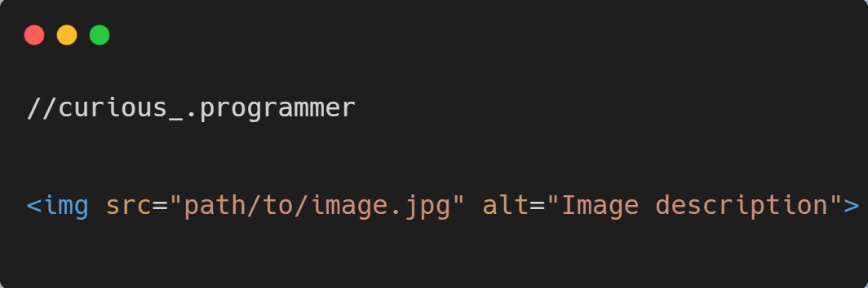

The alt attribute provides alternative text that is displayed if the image fails to load or for accessibility purposes. Make sure to provide a concise and meaningful description of the image.

* 1. **: Configuring Image Attributes:**

In addition to the source and alt attributes, you can configure other image attributes to control size, alignment, and more.

Width and Height: Use the width and height attributes to specify the image dimensions in pixels.

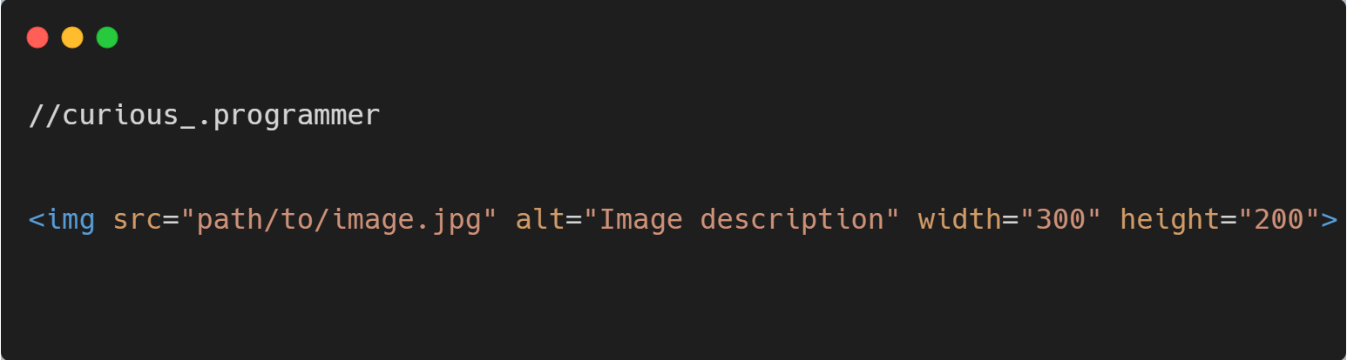

**4.3: Alignment:**

The align attribute can be used to align the image within the surrounding content.

However, it is considered outdated. CSS should be used for alignment instead.

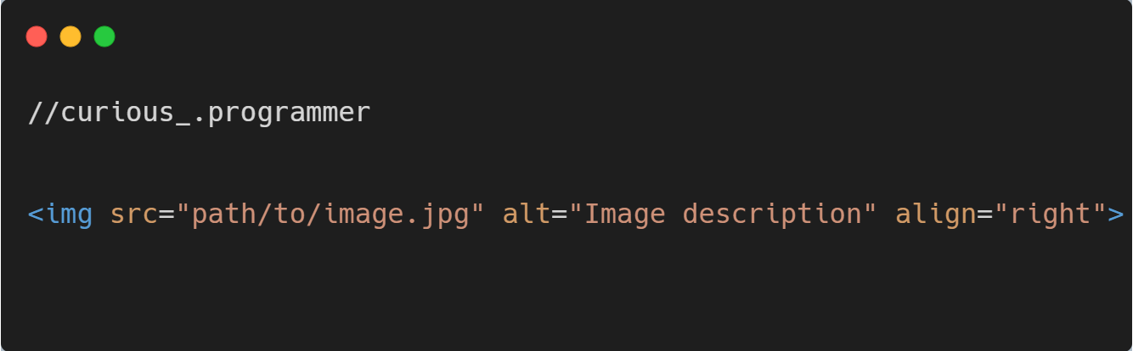

* 1. **: Embedding Videos:**

To embed videos in HTML, you can use the **<video>** tag. Specify the source file **(src)** using the src attribute and provide fallback content within the opening and closing **<video>** tags.

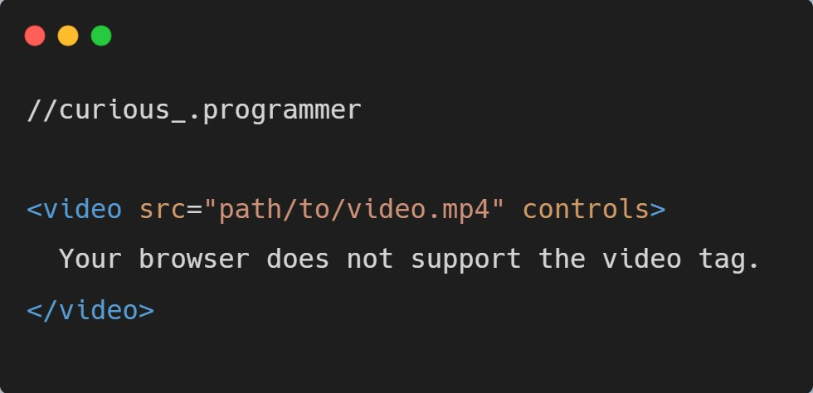

The controls attribute adds video controls **(play, pause, volume, etc.)** to the video player. You can also include alternative video formats **(<source> elements)** within the **<video>** tags to support different browsers.

* 1. **: Embedding Audio Files:**

To embed audio files, use the **<audio>** tag and specify the audio file source **(src)** using the src attribute. Similarly to video embedding, you can provide fallback content between the **<audio>** tags.

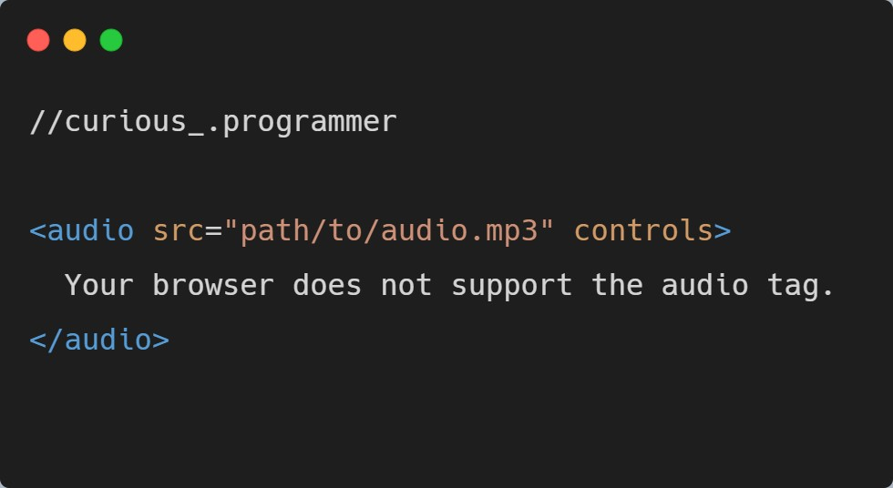

The controls attribute adds audio controls **(play, pause, volume, etc.)** to the audio player. You can also include alternative audio formats **(<source> elements)** within the **<audio>** tags for better browser compatibility.

By utilizing these HTML elements and attributes, you can seamlessly insert and display images, configure their attributes for size and alignment, and embed videos and audio files to enhance the multimedia experience on your webpages.

:

Tables play a crucial role in organizing and presenting tabular data on webpages. Let's explore how to create tables, define their structure, add headers, rows, and columns, and style them using CSS.

**Table Structure:**

HTML tables consist of rows and columns. The structure is defined using specific elements:

**<table>:** The main container for the table.

**<tr>:** Represents a table row.

**<th>:** Used for table headers. Typically placed within the **<tr>** element.

**<td>:** Represents a table cell, which holds the actual data.

**5.1 : Creating Table Structure:**

To create a table, we use the **<table>** element as the container for the entire table. Inside the **<table>** element, we define the table rows using the **<tr>** (table row) element. Each row consists of table data cells, defined by the **<td>** (table data) element.

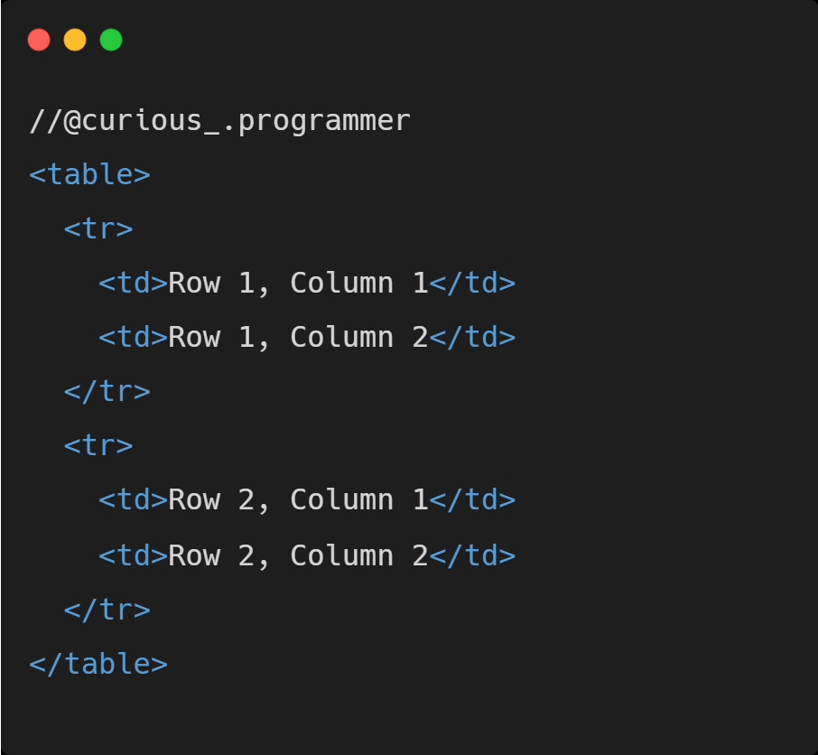

**5.2: Adding Headers, Rows, and Columns:**

To define table headers, we use the **<th>** (table header) element instead of **<td>.**

Headers provide context and help identify the content of each column or row.

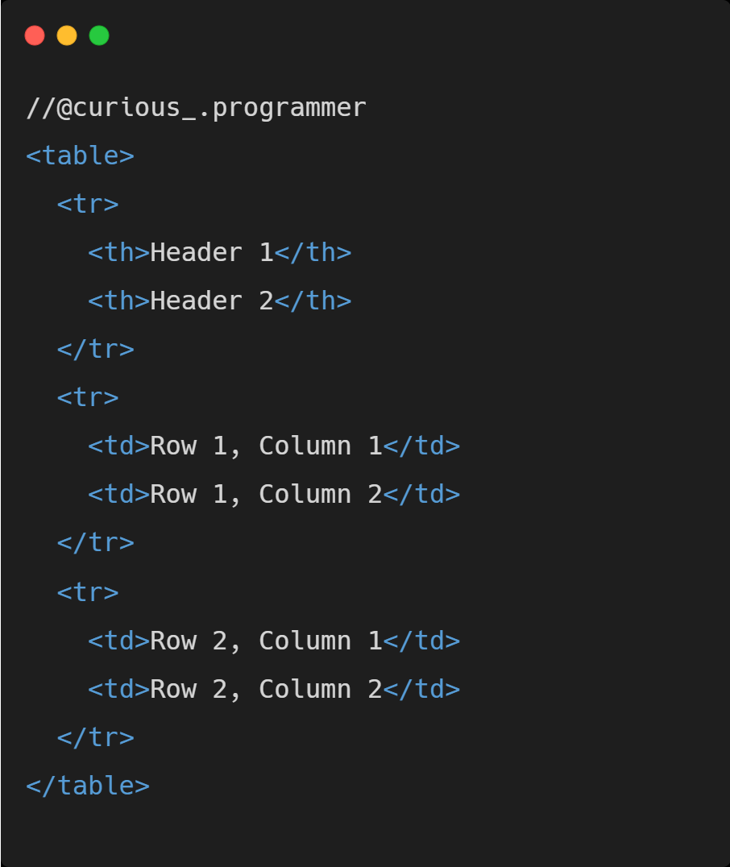

**5.3: Formatting Tables with CSS:**

CSS can be used to style and format tables to enhance their visual appeal and improve readability. We can apply CSS properties to various table elements, such as **<table>, <th>, <td>, and <tr>,** to control the table's appearance.

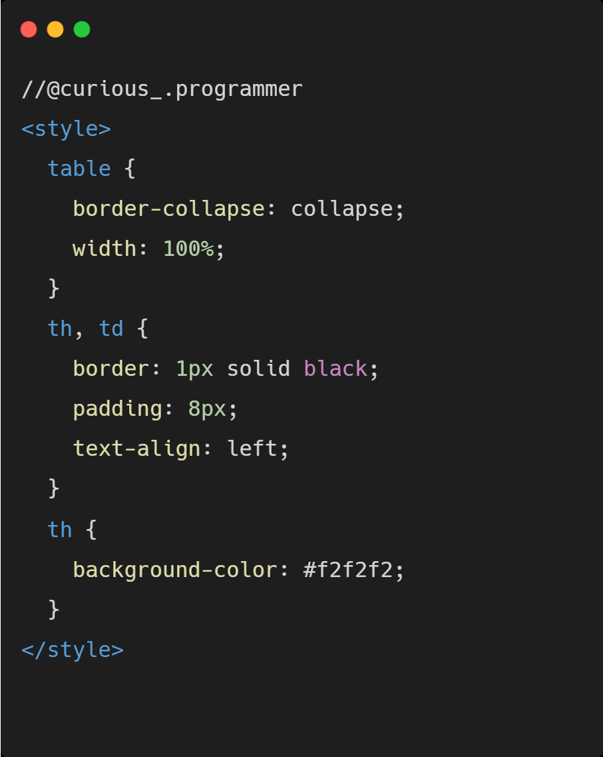

The CSS code above sets the table's border-collapse property to collapse, ensuring a consistent and clean appearance. It also applies a solid black border and padding to both table headers **(<th>)** and table data cells **(<td>).** The background color of the table headers is set to a light gray shade **(#f2f2f2)** for better differentiation.

By combining **HTML and CSS**, you can create tables, define their structure, add headers, rows, and columns, and style them to match your desired visual aesthetic. Tables provide a powerful way to organize and display data, making them a valuable tool in web development.

:

Forms play a crucial role in web development as they enable the collection of user input. By understanding form elements, you can create interactive and user-friendly experiences. Let's explore how to build forms, understand form elements, and handle form submission.

Forms are an essential component of web development, allowing users to provide valuable input and interact with websites. By understanding form elements, you can create intuitive and user-friendly experiences. Building forms involves using the <form> element as a container and specifying the action and method attributes to define where and how the form data will be submitted. Form elements such as text fields, checkboxes, radio buttons, and dropdowns provide users with various ways to input data. Each form element has its own attributes and behaviors, allowing you to customize their appearance and functionality. Once a user submits a form, form submission can be handled using server-side scripting languages or JavaScript to process and validate the data. Proper form handling ensures data integrity and enables efficient processing on the server side. By mastering forms and form elements, you can create dynamic and interactive web applications that empower users to contribute and engage with your website.

**6.1 : Building Forms:**

To build a form, use the **<form>** element as a container for all the form elements. The action attribute specifies the URL or server-side script where the form data will be submitted, while the method attribute defines the HTTP method to be used **(usually "GET" or "POST").**

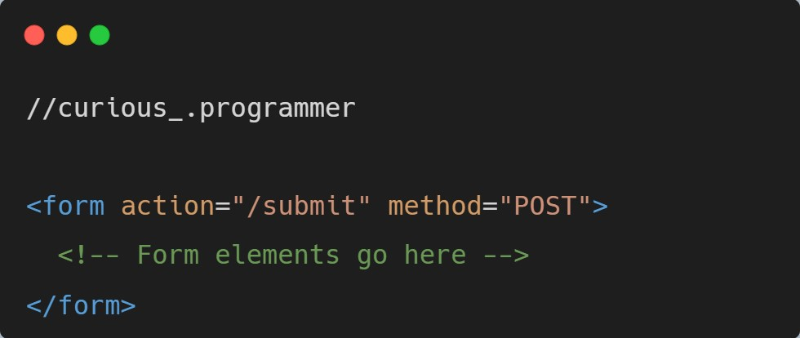

**6.2 : Form Elements:**

1. **Text Fields (<input type="text">) :** Text fields allow users to enter textbased input.

Use the **<input>** element with the **type="text"** attribute to create a text field.

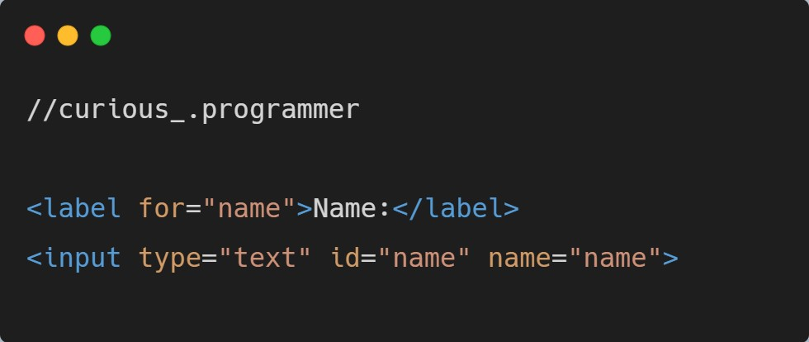

1. **Checkboxes (<input type="checkbox">) :** Checkboxes enable users to select one or multiple options from a list. Each checkbox should have a unique id attribute and a corresponding <label> element.

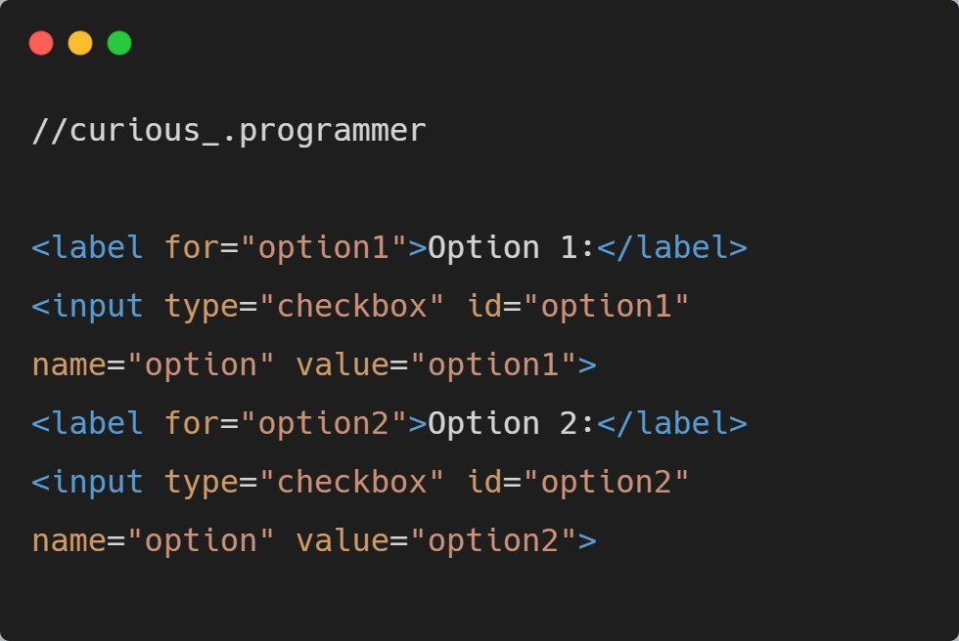

1. **Radio Buttons (<input type="radio">) :** Radio buttons allow users to select a single option from a group. They share the same name attribute but have different id attributes.

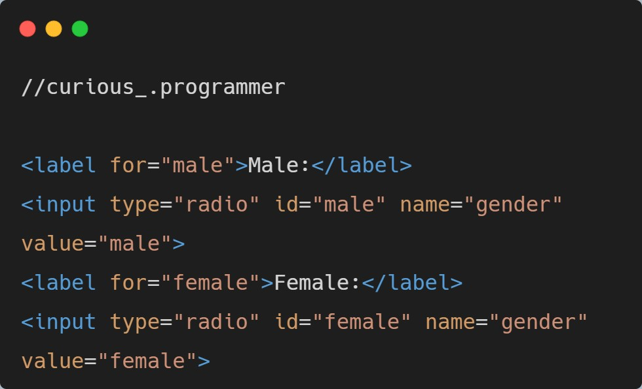

1. **Dropdowns (<select> and <option>) :** Dropdowns provide a selection of options from which users can choose. Use the **<select>** element to create the dropdown and **<option>** elements for individual options.

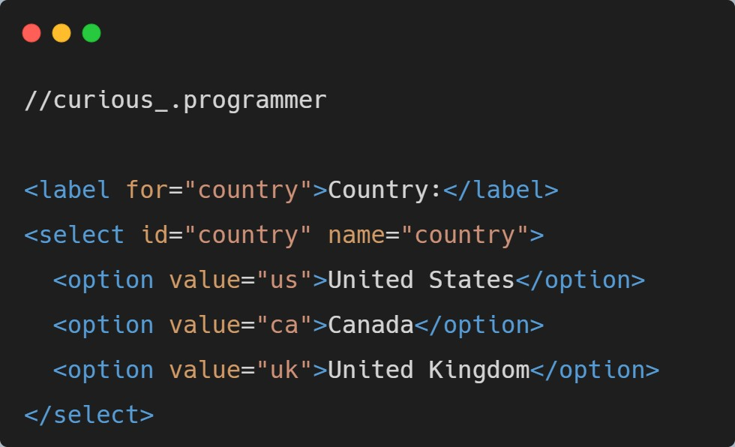

**6.3: Handling Form Submission:**

Form submission is typically handled using server-side scripting languages like PHP, Python, or JavaScript. The server-side script receives the form data and processes it accordingly.

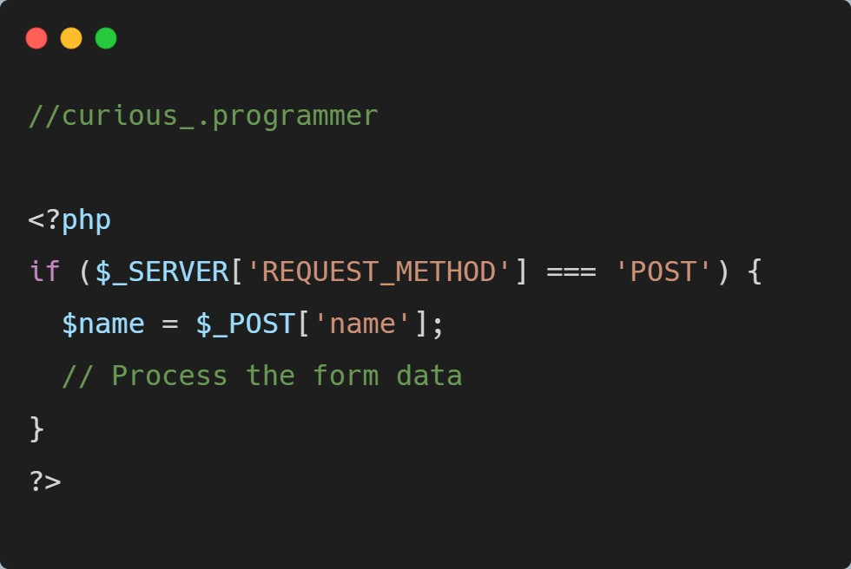

Ensure that the form's **action** attribute points to the appropriate server-side script or URL for data processing.

By understanding form elements, building forms, and handling form submission, you can create interactive and dynamic web experiences that collect user input efficiently.

:

* 1. **: Overview of CSS and its role in web design.**

CSS (Cascading Style Sheets) is a stylesheet language used to describe the presentation of a document written in HTML (Hypertext Markup Language). It is used to control the layout, formatting, and appearance of web pages. CSS provides a way to separate the structure and content of a web page from its visual representation, making it easier to maintain and update the design.

* 1. **: Inline styles, internal stylesheets, and external stylesheets.**

1. **Inline Styles:** Inline styles are applied directly to individual HTML elements using the **"style"** attribute. Inline styles have the highest specificity, meaning they override other styles applied to the element. Here's an example:

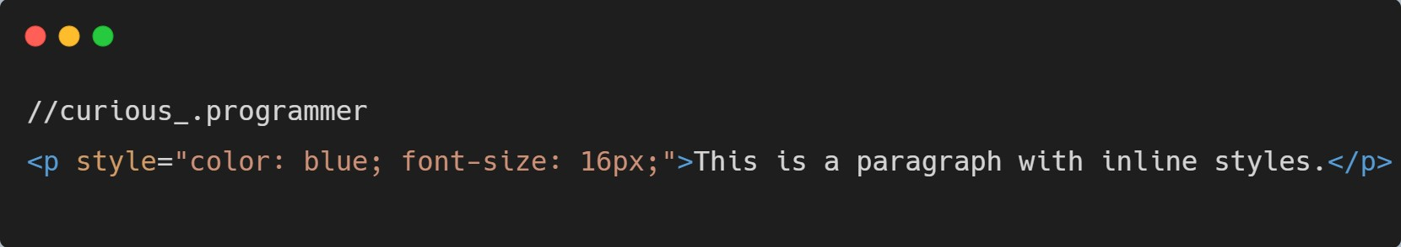

1. **Internal Stylesheets:** Internal stylesheets are defined within the "**head**" section of an HTML document using the **"style"** element. Internal styles apply to the entire document or specific sections defined by HTML elements.

Here's an example:

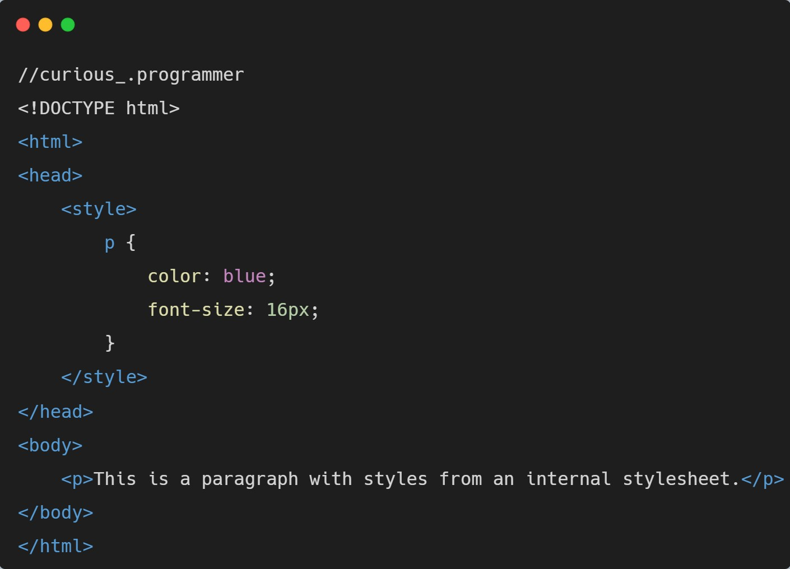

1. **External Stylesheets:** External stylesheets are defined in separate CSS files and linked to HTML documents using the **"link"** element. This approach allows for reusability and separation of concerns, as multiple HTML documents can share the same stylesheet. Here's an example:

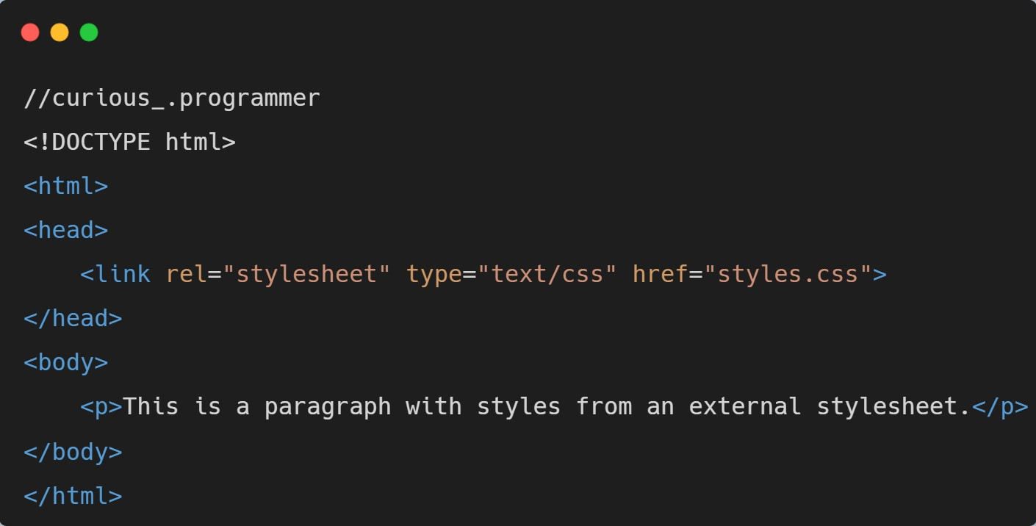

**7.3 : Applying styles to HTML elements (text formatting, backgrounds, borders).**

In each of these methods, you can apply styles to HTML elements using CSS properties. Some common examples include:

1. **Text Formatting:** CSS provides properties like **"color"** for specifying the text color, **"font-size"** for adjusting the font size, **"font-family"** for setting the font type, **"font-weight"** for controlling the text boldness, and many more.

1. **Backgrounds:** CSS allows you to set background properties such as **"background-color"** to define a background color, **"background-image"** to specify an image as the background, **"background-repeat**" to control how the background image is repeated, and so on.

1. **Borders:** CSS provides properties like **"border-width," "border-style," and "border-color"** to define borders around elements. You can adjust these properties to control the border width, style **(solid, dashed, etc.),** and color.

These examples are just a glimpse of what CSS can do. With CSS, you have extensive control over the visual aspects of HTML elements, enabling you to create appealing and well-designed web pages.

1. **1 : Understanding the importance of semantic markup.**

Semantic HTML refers to the use of HTML elements that convey meaning and structure to the content of a web page. It involves using elements that accurately describe the purpose and role of the content they enclose, making it more understandable to both humans and machines, such as search engines and screen readers. Semantic markup is essential for accessibility, search engine optimization (SEO), and maintaining a clear structure within a web page.

**8.2 : Using semantic elements like <header>, <nav>, <article>, <section>, etc.**

Here are some commonly used semantic elements and their purposes:

1. **<header>:** Represents the introductory content or a container for a group of introductory content at the beginning of a page or section. It typically includes site branding, main navigation, and introductory text.
2. **<nav>:** Defines a section of a page that contains navigation links allowing users to navigate within the website or different sections of the page.

1. **<article>:** Represents a self-contained, independent piece of content, such as a blog post, news article, or a forum post. It should make sense on its own and be able to be distributed or syndicated independently.

1. **<section>:** Represents a thematic grouping of content within a page. It helps in organizing content into meaningful sections and provides a semantic structure.

1. **<aside>:** Represents content that is tangentially related to the main content of the page. It is typically used for sidebars, pull quotes, advertisements, or other content that can be considered separate from the main content.

1. **<footer>:** Represents the footer of a section or the whole page. It usually contains information about the author, copyright information, contact details, or related links.

1. **<main>:** Represents the main content area of a document. It should be unique to the document and not contain any content that is repeated across a set of documents, such as site navigation.

Using semantic elements improves the accessibility of a website because screen readers and assistive technologies can interpret the structure and purpose of the content more accurately. Search engines also benefit from semantic markup, as they can understand the hierarchy and relationships between different parts of the page, improving the website's visibility in search results.

Additionally, semantic HTML promotes better code organization and maintainability. It helps developers and designers understand the purpose and structure of different sections, making it easier to maintain, update, and collaborate on projects.

By utilizing semantic elements appropriately, you create a more accessible, well-structured, and meaningful web page, improving the overall user experience and facilitating the interpretation of your content by both humans and machines.

* 1. **: Introduction to HTML5 and its new elements**

HTML5 is the latest version of the Hypertext Markup Language, which is the standard markup language used to structure and present content on the web. HTML5 introduces several new elements and features that enhance the capabilities and functionality of web pages. Here are some notable HTML5 features and elements:

* 1. **: Working with multimedia elements like <video>, <audio>.**

1. **<video>:** The <video> element allows you to embed videos directly into web pages without the need for plugins like Flash. You can specify the video source using the **"src"** attribute and control various aspects like playback controls, autoplay, loop, and more. Here's an example:

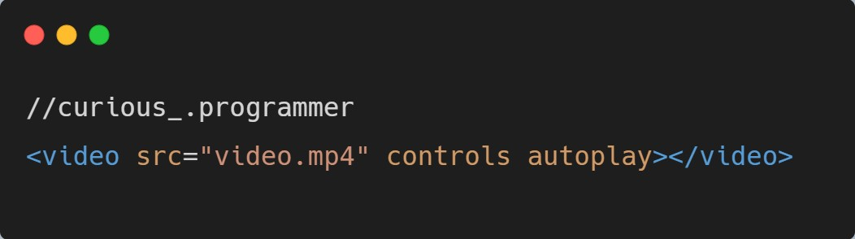

1. **<audio>:** The **<audio>** element is similar to the **<video>** element but specifically designed for embedding audio files. You can specify the audio source using the **"src"** attribute and control playback using controls such as play, pause, and volume. Here's an example:

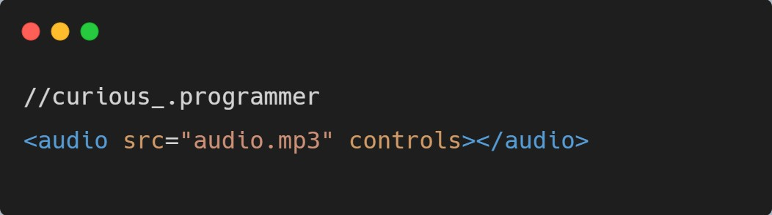

**9.2 : Using new form input types like <input type="date">, <input type="email">.**

1. **<input type="date">:** The type="date" input allows users to select a date from a calendar-like control. Browsers display a date picker to make it easier for users to input dates. Here's an example:

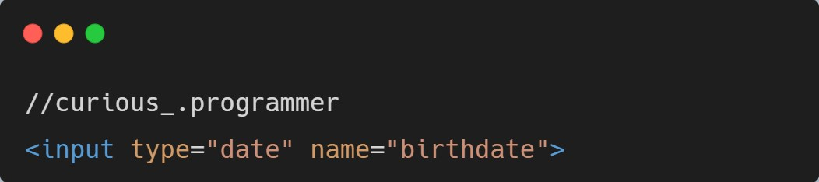

1. **<input type="email">:** The type="email" input is used for capturing email addresses. Browsers perform basic validation to ensure the entered value follows the email format. Here's an example:

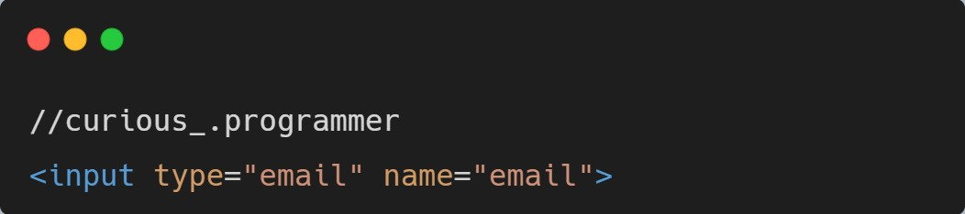

HTML5 also introduced other new input types like **type="url"** for capturing URLs, **type="number"** for numeric input, **type="range"** for sliders, **type="color"** for color pickers, and more. These input types help provide more specific input controls and enhance user experience.

It's important to note that while HTML5 introduced these new features, not all older browsers support them. To ensure cross-browser compatibility, you should provide fallback options or use JavaScript polyfills to provide similar functionality for older browsers.

By utilizing HTML5's new elements and features, you can enhance the interactivity, multimedia capabilities, and user experience of your web pages.

1. **.1 : Designing websites that adapt to different screen sizes.**

Responsive web design is an approach to designing and developing websites that ensures optimal viewing and interaction experiences across a variety of devices and screen sizes, including desktops, laptops, tablets, and smartphones. It aims to create flexible and adaptable layouts that can adjust and reflow content based on the device's screen dimensions.

**10.2 : Using media queries to apply styles based on screen dimensions.**

1. **Media Queries:** Media queries are CSS features that allow you to apply different styles based on the characteristics of the device or viewport. By defining specific breakpoints, you can target different screen sizes and apply different styles accordingly.

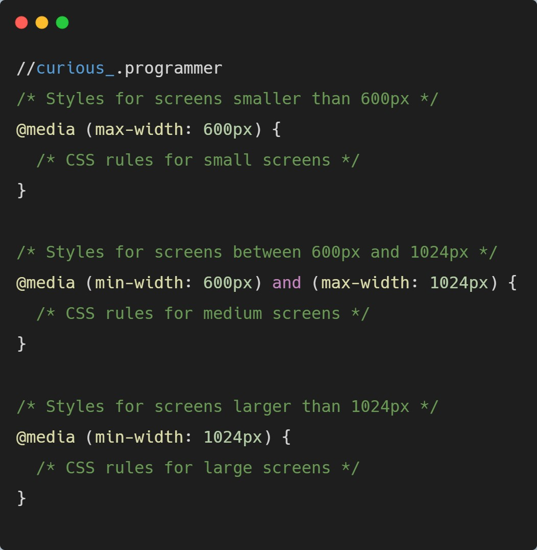

1. **Fluid Layouts:** Responsive web design often employs fluid layouts that use relative units (such as percentages) instead of fixed units (such as pixels) to size elements. This allows the content to automatically adjust and fill the available space proportionally. For example, instead of setting a fixed width for a container, you can use percentage-based widths. Here's an example:

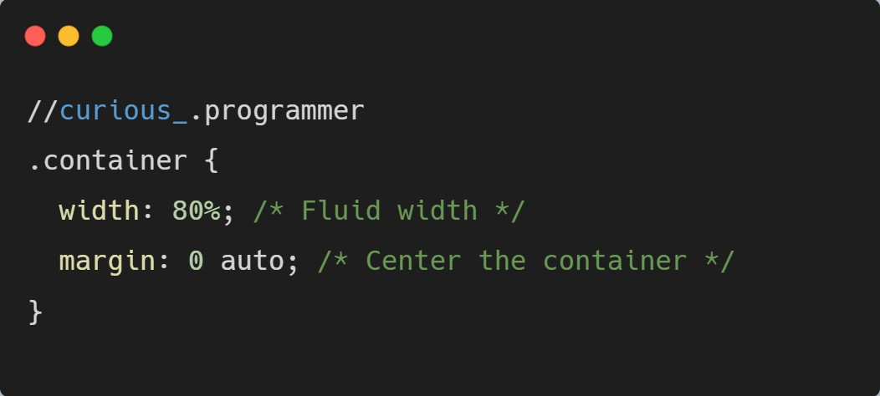

1. **Flexible Images and Media:** To ensure that images and media elements scale appropriately on different screen sizes, you can use CSS properties like max-width: 100% to make them responsive. This ensures that images and videos resize to fit their parent containers without overflowing or becoming distorted.

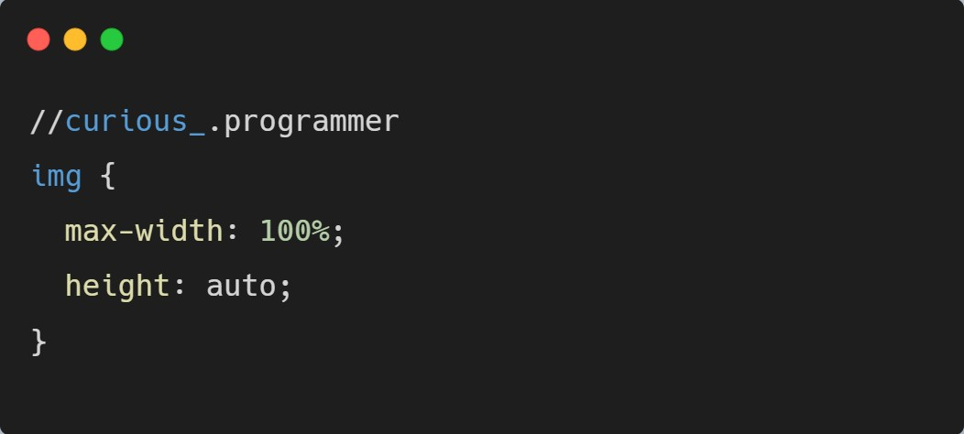

By combining media queries, fluid layouts, and flexible images, you can create responsive designs that adapt seamlessly to different devices and screen sizes. This approach enhances the user experience, making your website accessible and easy to navigate on any device.

It's worth noting that responsive web design is not limited to these techniques alone. Additional practices like mobile-first design, touchfriendly interactions, and performance optimization are also integral parts of creating successful responsive websites.

* 1. **: Ensuring websites are accessible to all users.**

Ensuring websites are accessible to all users is a crucial aspect of web design and development. Here are some key considerations and techniques for improving accessibility and usability:

* 1. **: Implementing proper semantic structure for screen readers.**

**1. Semantic Structure for Screen Readers:** Using proper HTML semantic elements and structure helps screen readers interpret and navigate the content accurately. This includes using elements like headings **(<h1> to <h6>)**, paragraphs **(<p>)**, lists **(<ul>, <ol>, <li>),** and other appropriate elements. These elements provide structure and hierarchy to the content, making it easier for screen readers to convey the information to users with visual impairments.

**11.3 : Using appropriate alt text for images.**

**2 . Alt Text for Images:** Providing meaningful alternative text (alt text) for images is essential for users who cannot see the images, including those who use screen readers or have images disabled. Alt text should describe the content or purpose of the image. For purely decorative images, it's appropriate to use empty alt attributes **(alt="")** or CSS background images instead.

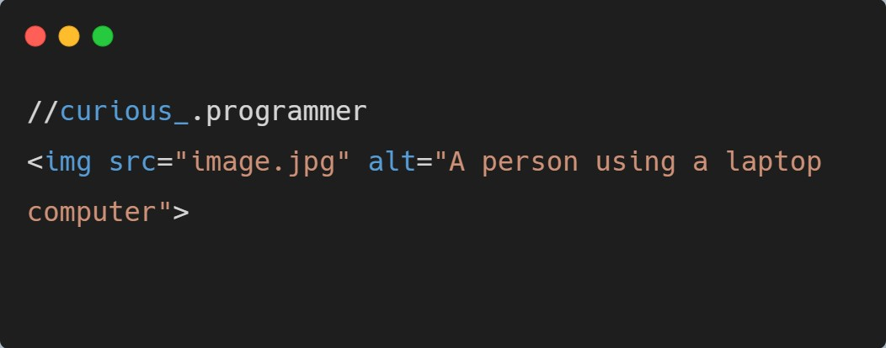

**11.4 : Keyboard navigation and focus management.**

1. **Keyboard Navigation and Focus Management:** Ensuring that your website is accessible via keyboard navigation is vital for users who cannot use a mouse. Make sure that all interactive elements (links, buttons, form inputs) are keyboard focusable and have appropriate focus styles. Also, ensure that the tab order follows a logical and meaningful sequence. You can use the **tabindex** attribute to control the order of focusable elements if necessary.

1. **Color Contrast and Readability:** Consider color contrast when designing your website to ensure that text is easily readable. Maintain sufficient contrast between text and background colors to accommodate users with visual impairments. There are tools available to test color contrast compliance, such as the Web Content Accessibility Guidelines (WCAG) standards.

1. **Clear and Concise Content:** Write clear, concise, and descriptive content to ensure that users can understand and navigate through your website easily. Use headings and subheadings to structure content, provide descriptive link text, and use plain language to enhance clarity.

1. **Form Accessibility:** Make sure form fields have clear labels associated with them using the **<label>** element or the aria-label attribute. This assists screen readers in identifying and associating labels with form controls. Provide appropriate error messages and hints to assist users in completing forms accurately.

Implementing these practices contributes to making your website more accessible and usable for a broader range of users, including those with disabilities. It's also recommended to follow accessibility guidelines, such as the WCAG, which provide comprehensive recommendations and standards for web accessibility. Regular testing and user feedback can help identify areas for improvement and ensure ongoing accessibility enhancements.

**12.1 : Incorporating JavaScript code into HTML pages.**

Incorporating JavaScript code into HTML pages involves placing the JavaScript code within <script> tags in the HTML document. Here's how you can integrate JavaScript into HTML:

1. **Inline JavaScript:** You can include JavaScript code directly within the

HTML file using the **<script>** tags. Place the **<script>** tags either within the <head> section or just before the closing **</body>** tag. Here's an example:

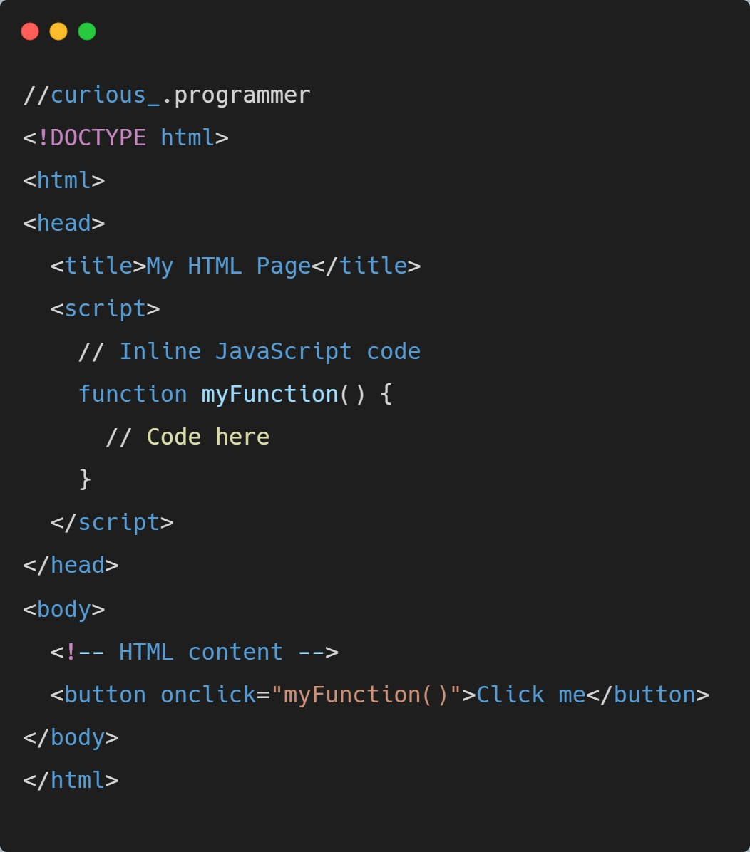

1. **External JavaScript file:** Alternatively, you can create a separate JavaScript file with a .js extension and include it in the HTML document using the **<script>** tag's src attribute. This allows for better code organization and reusability. Here's an example:

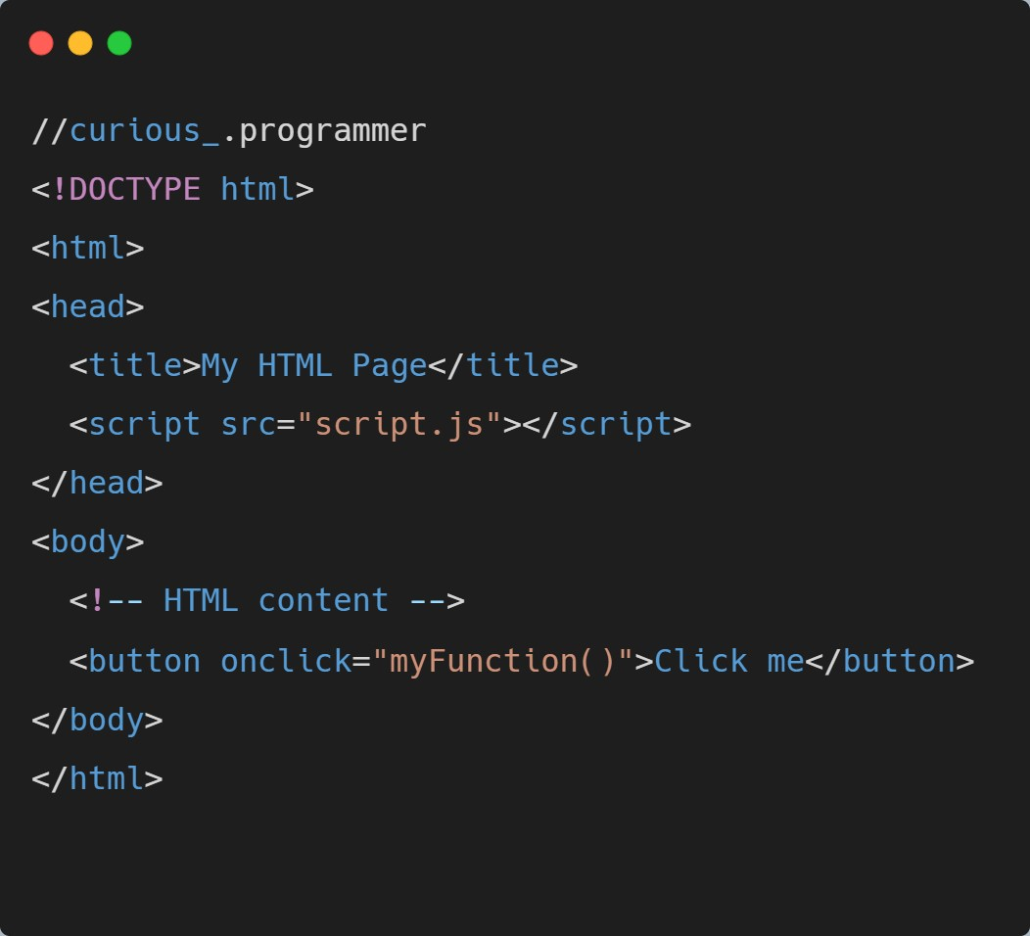

In the external JavaScript file (script.js in this case), you can define functions, variables, and interact with the DOM.

**12.2 : Handling events and interacting with the DOM:**

JavaScript allows you to handle events triggered by user interactions or other actions and manipulate the Document Object Model (DOM) to dynamically update the web page. Here's an example:

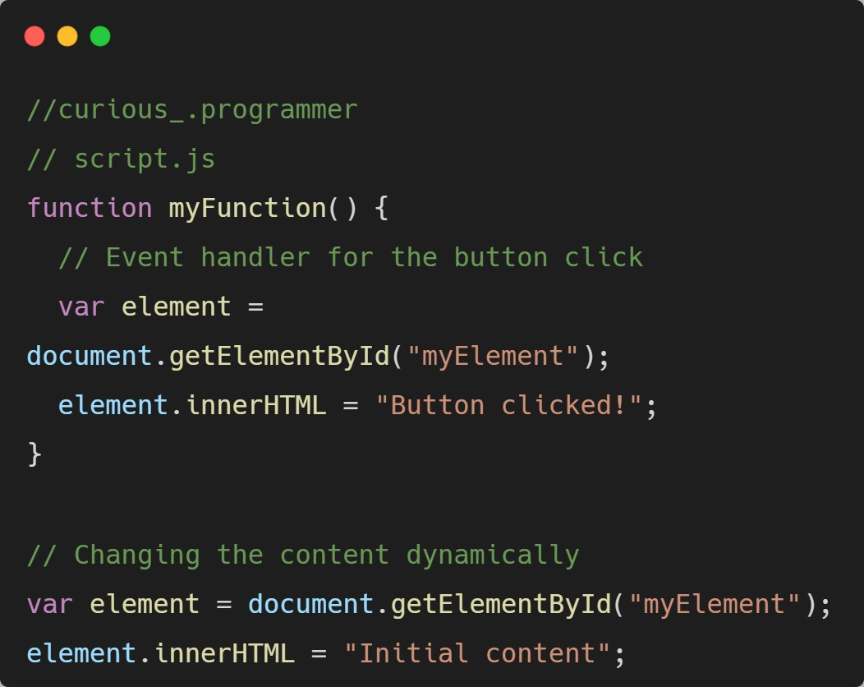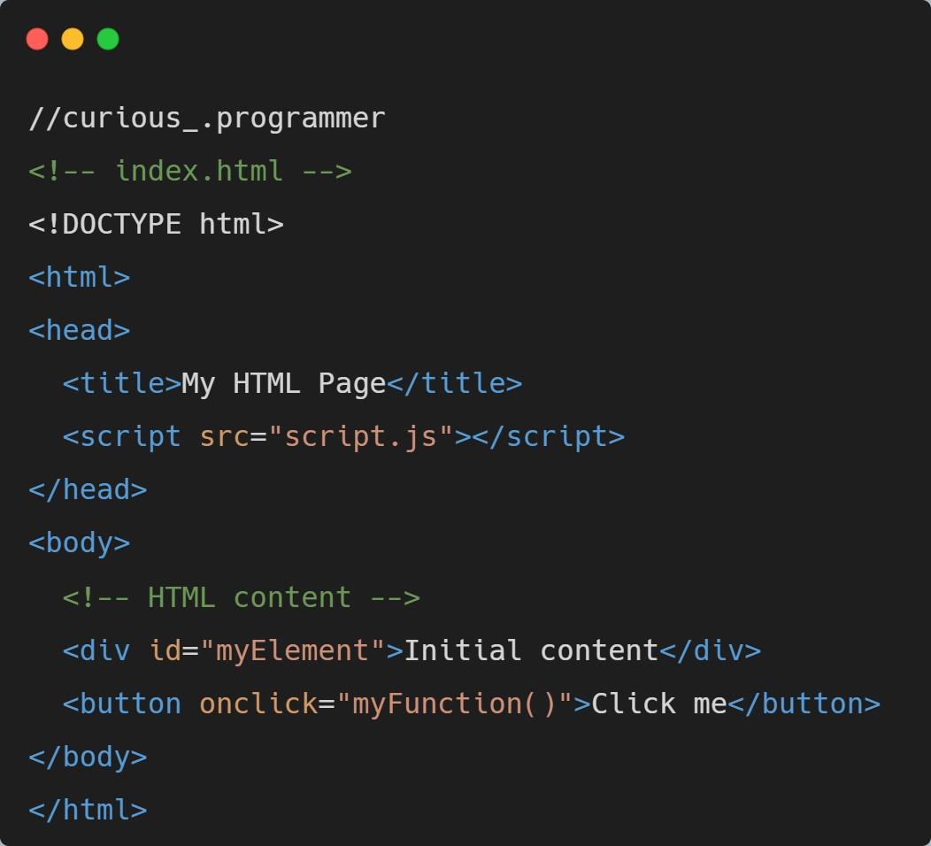

In this example, when the button is clicked, the **myFunction()** event handler is triggered. It locates the element with the ID "myElement" and changes its content to "Button clicked!".

JavaScript provides numerous event types, such as **click, mouseover, keydown, etc.**, which can be used to handle various user interactions. The DOM API allows you to access and manipulate HTML elements, modify their attributes, add or remove elements dynamically, and update their content.

By combining JavaScript with HTML, you can create interactive web pages that respond to user actions, update content dynamically, and provide a rich user experience.